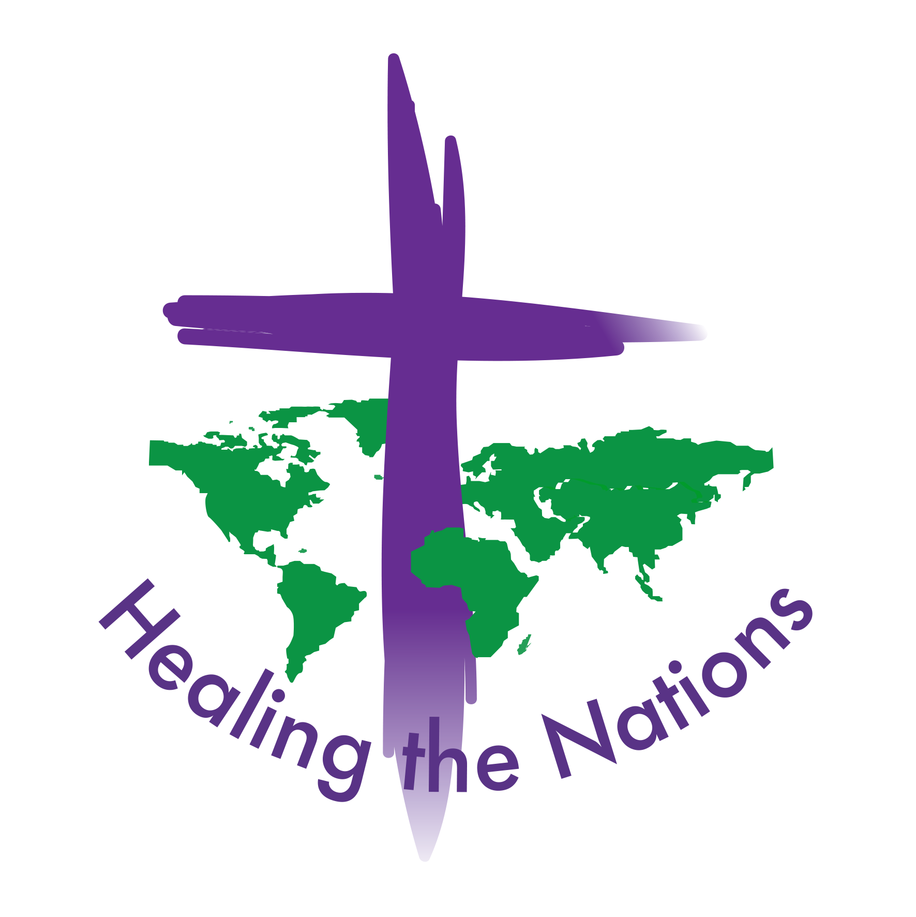
Healing the Nations
“Equipping the church to be an agent of healing and reconciliation in the midst of ethnic conflict” 12 Caroline Road Llandudno
Conwy
LL30 2TY
United Kingdom

Translating “Healing the Wounds of Ethnic Conflict” into local languages
Permission to Translate
We are encouraged that you would like to take up our passion for making this reconciliation material available to as many people as possible. If the following principles and requirements are adhered to, we are happy to give you permission for translation to be made.
Translation must be made from the most recent version of one of the Copyrighted, authorised editions in English, French, Arabic, Russian or Spanish. Copyright is held by: Mercy Ministries International CP442 1215 Geneva 15, Switzerland. Website: www.lerucher.org
If it is not possible to use one of these editions, permission should be sought from Dr Rhiannon Lloyd at Healing the Nations. The following two acknowledgements must be clearly made in the introduction to the new translation:
1.“Translated, with permission, from the original copyrighted authorized English (French, Spanish, Arabic, Russian) version, date …………,.”
2.“This material may be downloaded or printed and used free of charge. It may not be sold for profit (though you may recover printing costs) or the fundamental doctrinal and theological content changed.”
The process of translation
- Please come back to us if there is anything in the manuscript that you question or don’t fully understand.
- Graphics without words can be sent to you separately if you need them. You are also free to develop your own graphics, if the present ones are not culturally sensitive, or if you can think of better ones!
The following principles should guide your process of translation. They represent the highest standards of translation and if possible, they should be followed;
- The translators must understand the full content of the original text in English or whichever other authorized language they are using.
- They should read the whole chapters, to understand the flow of the material, then translate it in sections, rather than sentence by sentence.
- Ideas, rather than literal words, should be translated to avoid figures of speech and metaphors that would not be understood in the culture for which the translation is being made.
- We recommend a creative, free approach, rather than a wooden literal method. Use local idioms and examples. It is important that the main principles come across. To achieve this, you are free to use local stories and approaches, such as story telling. Above all else, it is important to be culturally appropriate.
- Because of this creative approach, a 3rd person, fluent in both languages, should check the translation. By comparing it with the original, they should look for any misunderstandings or inaccuracies and then agree their correction with the translator.
- When all is finally complete, please send us a copy of the translation, explaining who has made it and by whom it has been checked. We ask that no other translation be made from your translation but that further translations be referred back to us for approval.

Every blessing in your translation work!
Dr Rhiannon Lloyd July 2014 rhiannonlloyd13@gmail.com

In partnership with Mercy Ministries International www.lerucher.org & Micah Network www.micahnetwork.org

